Supplementary Notes:
- Alpha value as a reliable indicator of tumor purity
To demonstrate alpha value is a reliable indicator of tumor purity, we compare the alpha values of the same CpG sites between primary and recurrent tumor samples. We find that the differentially methylated CpG sites (DMCs) with high alpha values in primary tumor samples also present high alpha values in the matched recurrent tumor samples (Supplementary Figure S3). It is reliable to use these largest alphas values to represent the earliest methylation changes during tumorgenesis. Thus, they are related to the tumor purity.

- Details of tumor purity detection
  - Comparison of sample dependent DMCs with tumor type dependent DMCs
We compare tumor purity estimated from sample dependent DMCs with that estimated from tumor type dependent DMCs in BRCA, LUAD, and KIRC to demonstrate sample dependent DMCs is outperformed. In order to obtain tumor type dependent DMCs, we first detect stable CpG sites based on the normal samples of each cancer type. Then we compare their methylation levels between tumor and normal samples using Wilcoxon rank sum test, and select top 1000 most significant stable CpG sites as tumor type dependent DMCs. Finally, we use these tumor type dependent DMCs to estimate tumor purity for tumor samples in each tumor type. The results show that our sample dependent DMCs performs better than that by tumor type dependent DMCs (Supplementary Table S4). In addition, the tumor type dependent method requires enough normal samples for DMC detection in each tumor type. Therefore, it cannot be used for cancer types with less normal samples, e.g. Ovarian serous cystadenocarcinoma (OV) has 0 normal samples and Glioblastoma multiforme (GBM) has 2 normal samples in TCGA. For our method (sample dependent DMCs), it can be easily applied on these cancer types.
  - Introduction of Beta Mixture Model (BMM)
Currently, many models can be used to get clusters, such as Gaussian mixture model (GMM) and BMM. However, different methods have different advantages, such as BMM is outperformed than GMM on bounded data (Ma and Leijon, 2011), and it has been applied in many research fields, such as image processing, gene expression correlation analysis and somatic single nucleotide polymorphism clustering for subclone analysis (Ma and Leijon, 2009, Ji, et al. 2005, Miller, et al. 2014). Here we adopt BMM since the alpha values are bounded.
The probability density function of the beta distribution is
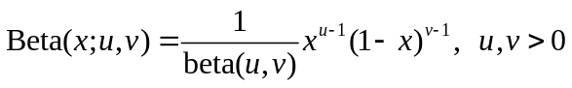 (2.1)
where 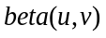 is the beta function. The multivariate BMM is
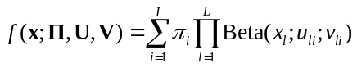 (2.2)
where And 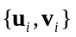 denote the parameters vectors of i-th mixture component and because our data is one-dimensional data, 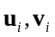 are two one-dimensional vectors in our model.
  - The estimation of alpha value
For i-th DMC, its alpha value 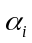 is defined as 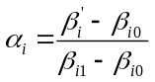, represents the percentage of tumor cells whose methylation status has changed. In the definition, 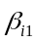 represent the beta value of tumor cells whose methylation level is changed, 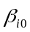 represent the beta value of cells whose methylation level is the same as that in normal cells and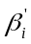 is the methylation level observed in the mixed sample. In calculation, 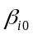 is estimated by the mean of the beta values of i-th DMC in the pool of normal samples, and 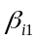 is estimated by 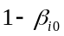. In theory, alpha value will not be larger than one, however, we found a few alpha values larger than one (Supplementary Table S5). This may be caused by errors in beta value calculation, and we removed them in our following steps.
  - The K-part mixture model
As shown in Supplementary Figure S2, different cells may have different changes of methylation levels during tumorgenesis. Thus, different DMC may have different alpha values. We define the K-part mixture model to simulate the different alpha values caused by the different periods of DMCs generation. For each type of DMCs, we use a beta distribution to simulate the distribution of its alpha values, and assume that there are a total of K types of DMCs. Then we use BMM to cluster these alpha values and find these K types of DMCs.
  - Variational Bayesian mixture modeling of beta distributions
We model the probability of an alpha value at one CpG site belonging to cluster j as
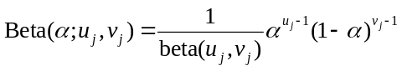
We extend this to the case with N sites and K beta components and then we can get the conditional distribution
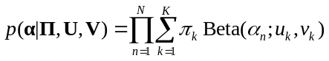
Where 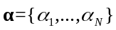 denotes the alpha values of all CpG sites with significant differences, 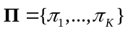 and 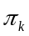 denotes the probability that an alpha belongs to component k, N denotes the total number of CpG sites we selected and K denotes the number of clusters. We initialize K = 10, which is larger than our expectation of the cluster number in most of the samples. In addition, it can avoid the data under-fitting due to the complexity of real tumor sample data (more details in section 3.2).
All parameters need to be learned in the mixture model are 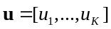, 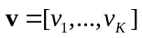, 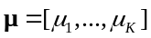, 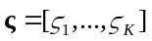, 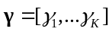, 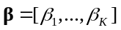, 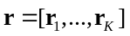, 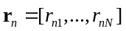, 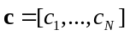. We use the method of Ma and Leijon¹ to learn these parameters using Bayesian estimation with variational inference. Ma and Leijon¹ use two gamma distributions 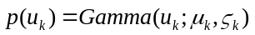 and 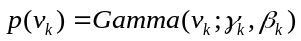 as the prior distributions of the each beta distributions parameter 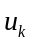 and 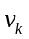 , and use Dirichlet distributions 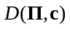 as the prior distributions of 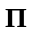. For each observation 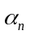, the corresponding 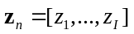 is a vector with only one element value of 1 and all the other elements value of 0. If the i-th element is 1, it means that the n-th position belongs to cluster i. 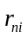 denotes the probability that the n-th site belongs to the i-th cluster. It is calculated by equation (17) and (18) in Ma and Leijon’s study. We use K-means clustering algorithm to get the initial cluster centers and initialize these parameters and we use equation (31) - (36) in Ma and Leijon’s study to update these parameters iteratively unless the maximum number of iterations is reached.
  - Cluster pruning and assignment
We remove the cluster if it represents a small portion of the data set. We calculate it by
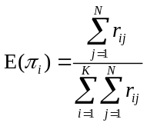
where 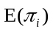 denotes the expectation of 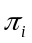 during this iteration. We will discard those clusters whose value is less than the threshold (default is 0.01). After removing, we start a new iteration until all the clusters’ values are greater than the threshold or the current number of clusters has been reduced to less than half of the initial number of clusters. And to be simple, we determine which cluster the j-th site belongs to by selecting the maximum value of the probability from 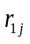 to 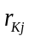. If is the largest, then the j-th site belongs to i-th cluster.
  - Tumor purity detection
After we get the result of alpha value clustering, we need to use this result to calculate tumor purity. We calculate the mean of alpha values in each cluster and take the maximum mean as the tumor purity.

- Selection of hyperparameters
  - The selection of n and k
In the process of selecting stable CpG sites, if the value of n is too small, we cannot obtain sufficient CpG sites for accurate clustering that will result in inaccurate tumor purity estimation. If the value of n is too large, many sites with large standard deviations will be selected. Based on these sites, it is difficult to accurately determine whether the DMC is caused by the large heterogeneity in normal or caused by the differences between normal and tumor sample.
For the parameter k, if it is too small, it will lead to the screening of too many CpG sites that are not meaningful to purity. That is because CpG sites with large beta value changes correspond to larger alpha values and correspond to the common features of tumor cells. These extra selected sites, which have smaller beta changes, are often caused by errors in beta values or due to changes in a small fraction of tumor cells. The incorporation of these sites will affect the accuracy of purity estimation. In addition, too many sites will make the algorithm slower. If the value of k is too large, it will result in DMCs with largely changes of DNA methylation in tumor samples, which is good for samples with large tumor purity. However, the tumor samples with small tumor purity exhibit medium or small changes of DNA methylation comparing to normal samples, and the purity of these samples cannot be correctly estimated based on DMCs with largely DNA methylation changes. In conclusion, either too large or small k affects the tumor purity estimations.
We compare the results of the purity on the TCGA tumor samples on different parameters, and use the correlation with Infiniumpurify to evaluate the performance. In our results, when n set to 70000 and k set to 20 we can obtain the best performance (Supplementary Table S6). Therefore, we choose n equals to 70000 and k equals to 20 as the default values of the hyperparameters.
  - The selection of initial cluster number
For parameter K, which is the upper bound of cluster numbers, and the optimal cluster number is determined during iteration process. After we give the initial K value, the cluster number will decrease as the iteration progresses until it reaches an optimal value. In our data, we find that the optimal cluster number is stable when setting different initial values. We test this on LUAD data with different initial K values (the other hyperparameters are set to default values). When K varies from 12 to 18, we select all LUAD samples for testing. When K varies from 20 to 50 we select those samples with enough DMC sites to test to ensure samples can find K initial center points during K-means process. We find that the final number of clusters for most samples is less than 10 (Supplementary Figure S4). Therefore, we initialize K to 10, which is larger than the optimal number of clusters in most of the samples. Furthermore, it can reduce unnecessary calculations caused by too many initial clusters.

- The impact of SNPs on tumor purity results
We know that some CPG sites are annotated as SNPs. In the 70,000 stable CPG sites we selected, we find 9869 stable CpGs (14%) annotated as SNPs. To understand the effect of these SNP associated stable CpG sites, we remove these sites and test the performance on all TCGA samples (the other hyperparameters are set to default values). The correlation between the purity obtained by this method and the results of Infiniumpurify is 0.799, which is not much different from the result of retaining the CpG sites with SNPs (0.794). We compare the results of the two methods and find that the results are almost same (cor = 0.95, Supplementary Figure S5). This suggests that the CpG sites with SNPs have little effect on our results.
Supplementary Figures.
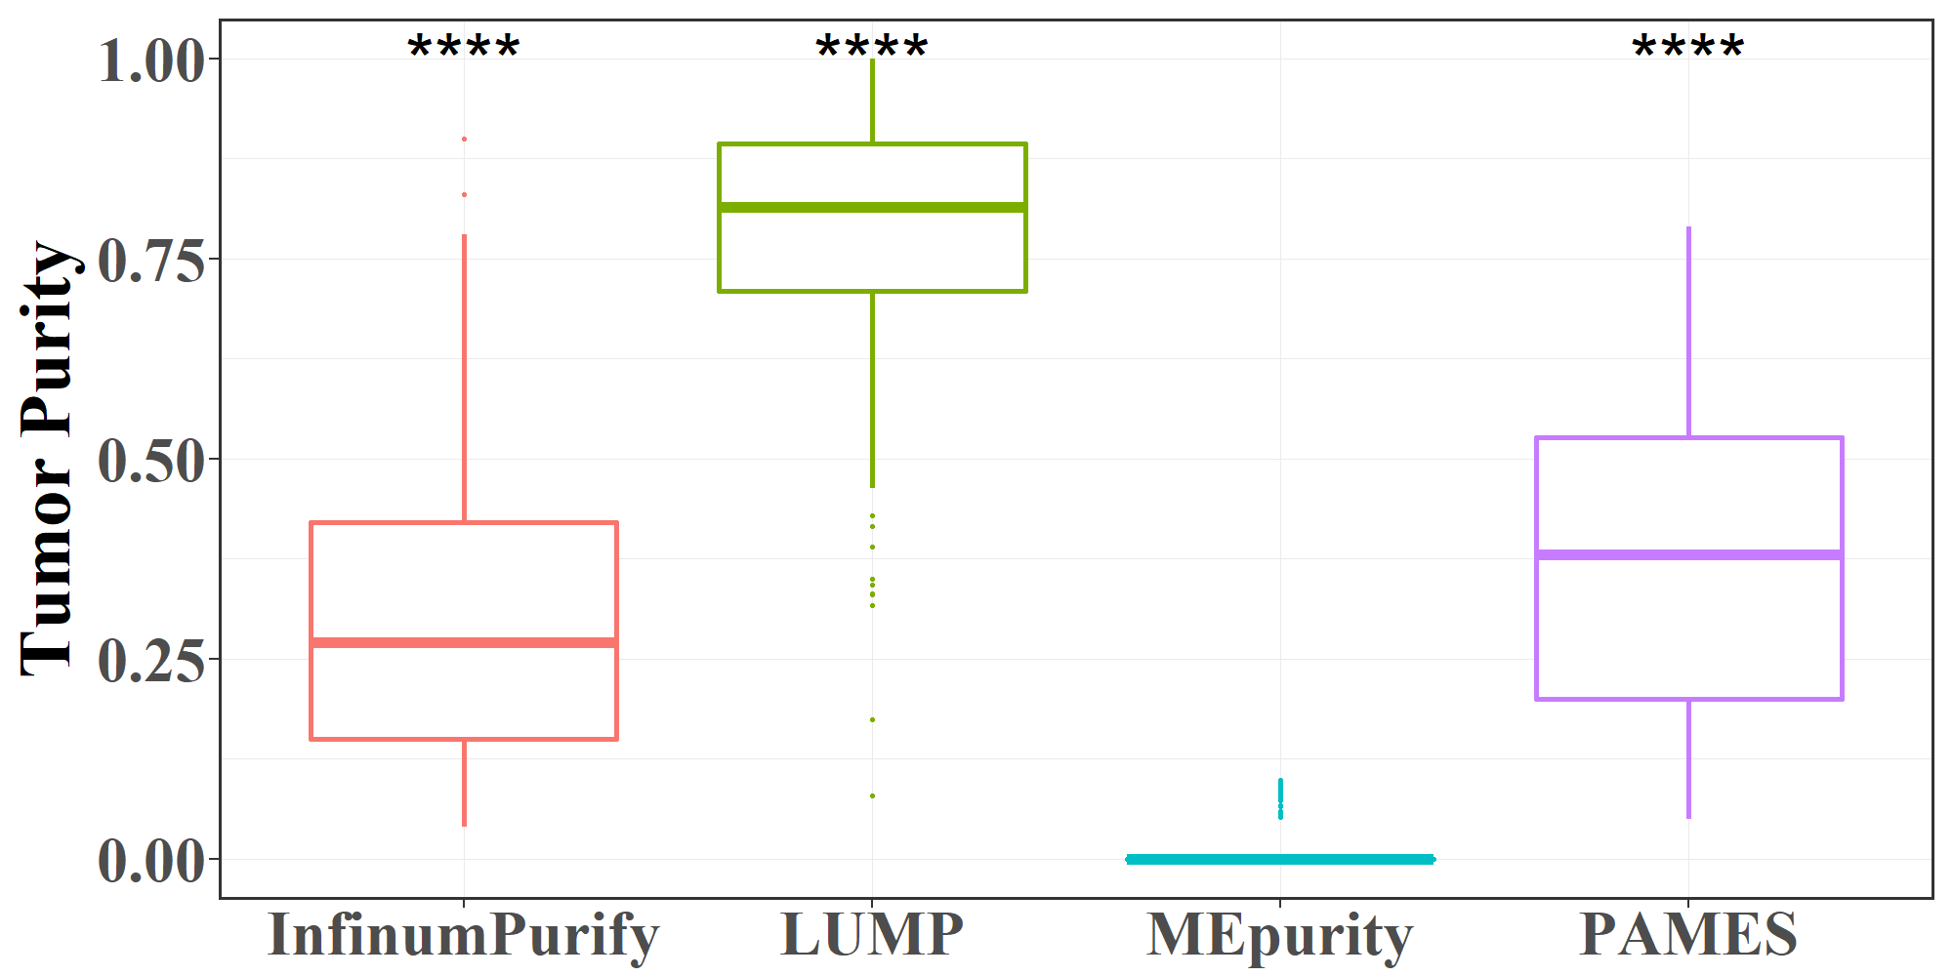

Supplementary Figure S1 | Tumor purity estimation on TCGA normal samples. The purity results estimated by MEpurity are significantly lower than purity estimated by the other three methods. It shows that MEpurity works better on normal samples than the other three methods.

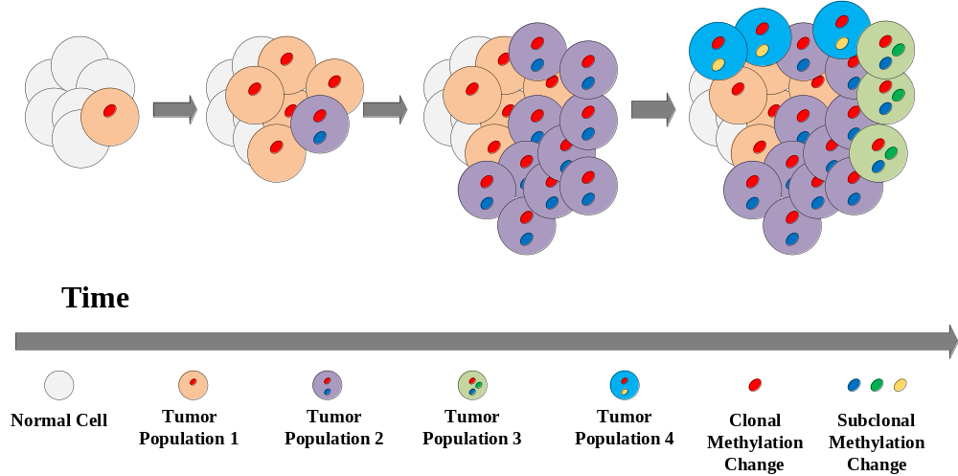

Supplementary Figure S2 | Different methylation level changes carried by different cells during tumor oncogenesis. Different cells carry different changes of methylation level during tumor oncogenesis. In this figure, each elliptical point represents a DMC. Therefore, for different DMCs, the alpha value may be different. For example, for the sites represented by red color and yellow color, the expected alpha values are 31/37 and 3/37, respectively.

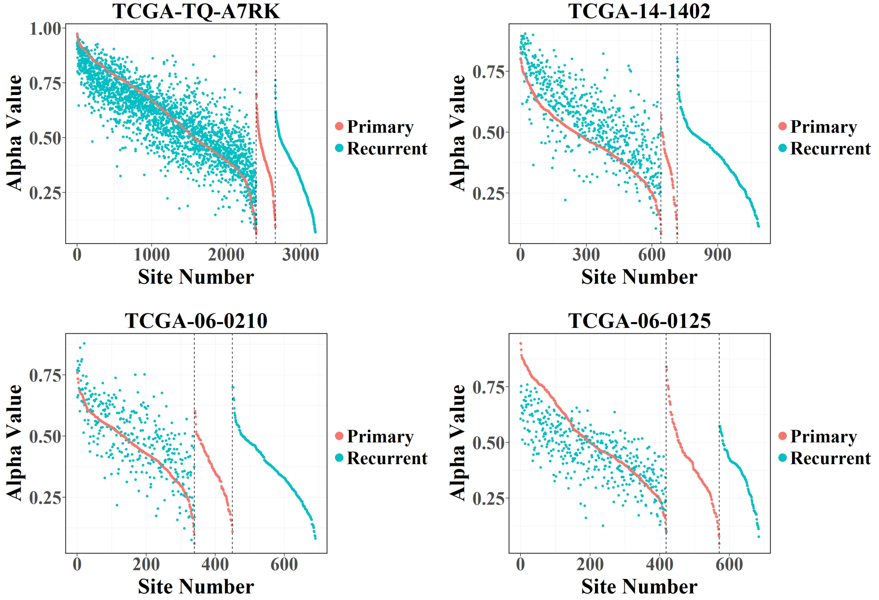

Supplementary Figure S3 | Different alpha status in primary tumor sample and recurrent tumor sample. Each point represents a DMC. The X-axis represents the number of DMCs, and the Y-axis represents the alpha value of DMCs. Each picture is divided into three areas. The leftmost region represents DMCs in both primary and recurrent samples, the middle region represents DMCs only in primary samples, and the right region represents DMCs only in recurrent samples.

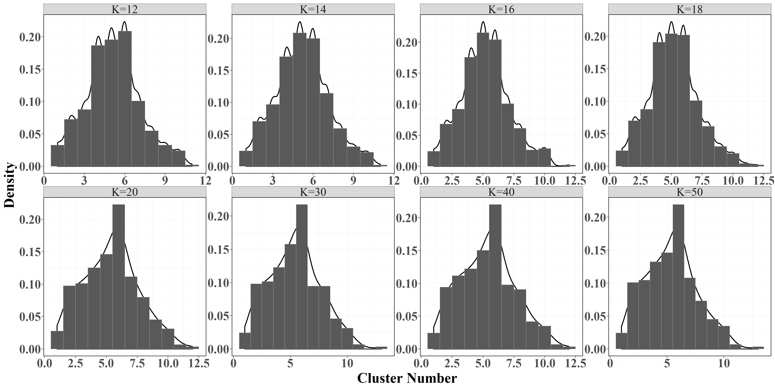

Supplementary Figure S4 | Number of clusters finally obtained when K takes different initial values. For parameter K, which is the upper bound of cluster numbers, and the optimal cluster number is determined during iteration process. After we give the initial K value, the cluster number will decrease as the iteration progresses until it reaches an optimal value. In our data, we find that the optimal cluster number is stable when setting different initial values. We let K take different values and test it on the TCGA LUAD tumor samples to see the number of clusters when the algorithm finally converges. The results show that, regardless of the value of K, the final number of clusters for most samples is smaller than 10. Therefore, we initialize K to 10, which is an overestimate of our expectation of the number of clusters most of the time. It can both avoid the data under-fitting due to the complexity of real tumor sample data and avoid unnecessary calculations caused by too many initial clusters.

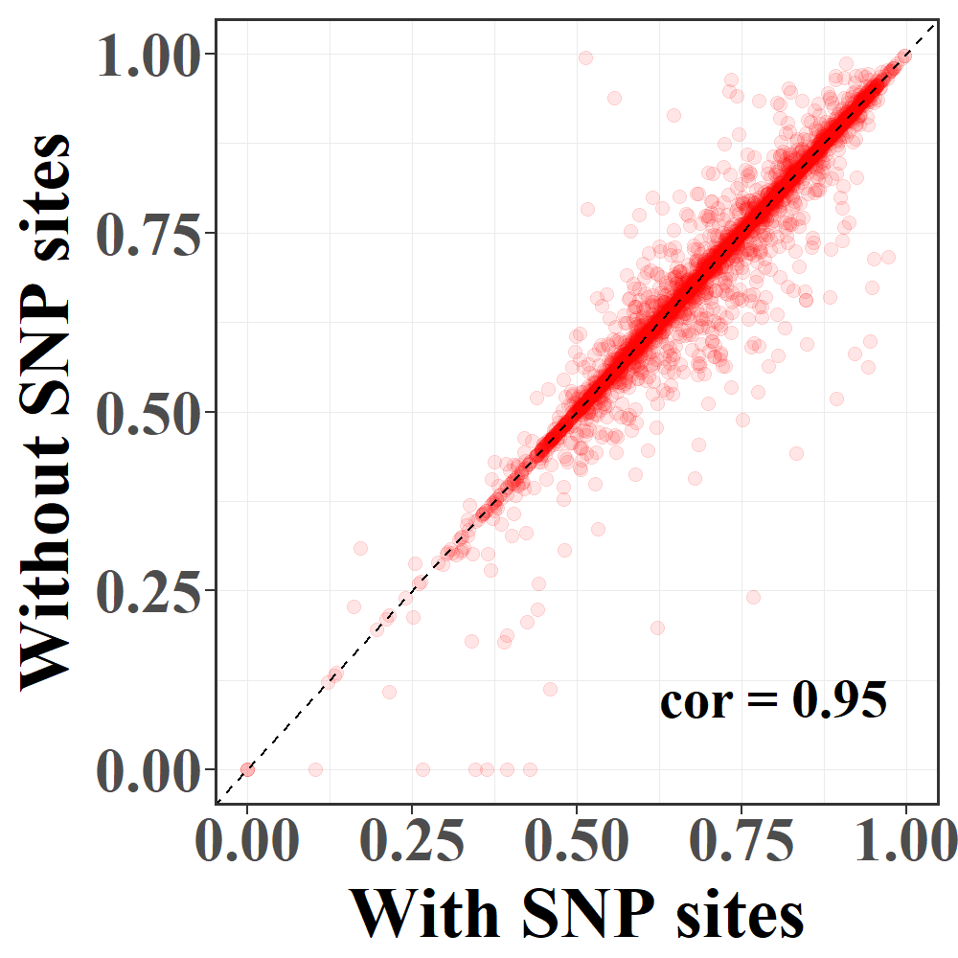

Supplementary Figure S5 | Effect of CpGs annotated as SNPs on the results of tumor purity. To detect the effect of CpGs annotated as SNPs on the results of tumor purity, we remove 9869 stable CpGs annotated as SNPs and tested its performance on all TCGA samples. The results show that these CpGs have little effect on the results of tumor purity.
Supplementary Tables.

Table S1. Tumor purity estimation on TCGA tumor samples in detail.
Table S2. Tumor purity estimation on cancer cell line data in detail.
Table S3. Tumor purity estimation on TCGA normal samples in detail.
Table S4. Correlations between the results of MEpurity under different DMCs detection conditions and the results of Infiniumpurify.
Table S5. The number of DMCs with alpha value greater than one in some tumor samples.
Table S6. Correlations between the results of MEpurity under different hyperparameters and the results of Infiniumpurify.

Supplementary References.
Ji, Y., et al. (2005) Applications of beta-mixture models in bioinformatics. Bioinformatics, 21, 2118-2122.
Ma, Z. and Leijon, A. (2009) Beta mixture models and the application to image classification. International conference on image processing, 2045-2048.
Ma, Z. and Leijon, A. (2011) Bayesian estimation of beta mixture models with variational inference. IEEE Transactions on Pattern Analysis & Machine Intelligence, 33, 2160.
Miller, C.A., et al. (2014) SciClone: inferring clonal architecture and tracking the spatial and temporal patterns of tumor evolution. Plos Computational Biology, 10 (8), e1003665.

